**Expense Tracking**

# Project Report

**<Version 1.0>**

## Industrial Training

**BACHELOR OF TECHNOLOGY (CSE)**

PROJECT GUIDE: SUBMITTED BY:

**Ashish Bishnoi Neha Verma**

**(TCA-1909064)**

0 2-December-2022



**Faculty of Engineering**

**TEERTHANKER MAHAVEER UNIVERSITY, MORADABAD**

# ACKNOWLEDGEMENT

I express my deepest sense of gratitude towards my project guide **Mr. Aditya Jain** for his patience, inspiration, guidance, constant encouragement, moral support, keen interest, and valuable suggestions during preparation of this Project report.

My heartfelt gratitude goes to all faculty members of Computer Science & Engineering Dept., who with their encouraging and caring words and most valuable suggestions have contributed, directly or indirectly, in a significant way towards completion of this Project report.

I am indebted to all my classmates for taking interest in discussing my problem and encouraging me.

I owe a debt of gratitude to my father and mother for their consistent support, sacrifice, candid views, and meaningful suggestion given to me at different stages of this work.

Last but not the least I am thankful to the Almighty who gave me the strength and health for completing my report.

**Student Name – Neha Verma**

**Enrollment-Number – TCA2011009**

# DECLARATION

I, Neha Verma (TCA 1909064), student of B.TECH[CSE],VII Semester, hereby declare that this Project Report “EXPENSE TRACKING” submitted by me and approved by our project guide, the College of Computing Sciences and Information Technology (CCSIT), Teerthanker Mahaveer University, Moradabad, is a bonafide work undertaken by me.

The information and data given in the report is authentic to the best of our knowledge.

This Project Report is not being submitted to any other University for award of any other Degree, Diploma and Fellowship.

Date- 05/12/2022

Student Name- Neha Verma

|  |  |
| --- | --- |
|  |  |
|  |  |
|  |  |
|  |  |
|  |  |
|  |  |

certificate:

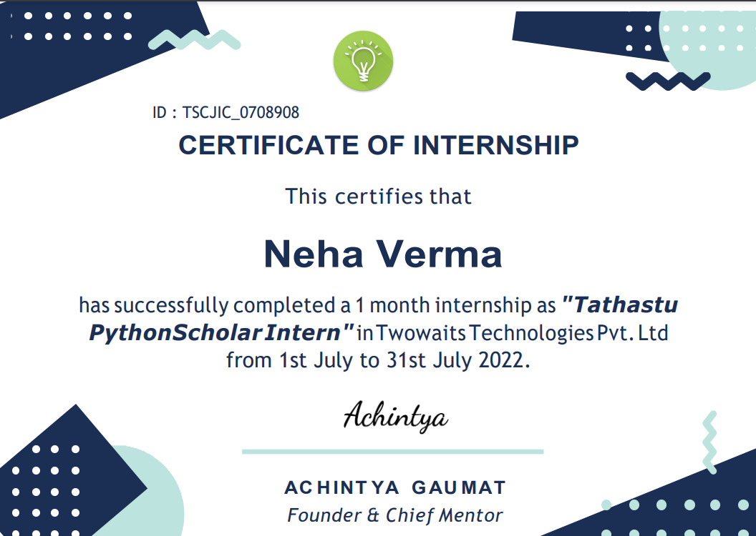

# Table of Contents

1. **PROJECT TITLE ............................................................................................................................................. 7**
2. **PROBLEM STATEMENT ................................................................................................................................ 7**
3. **PROJECT DESCRIPTION ................................................................................................................................ 7**

### 3.1 SCOPE OF THE WORK ......................................................................................................................................... 7 3.2 PROJECT MODULES ........................................................................................................................................... 8

3.3 CONTEXT DIAGRAM (HIGH LEVEL) ........................................................................................................................ 9

1. **IMPLEMENTATION METHODOLOGY..............................................................................................................9**
2. **TECHNOLOGIES TO BE USED........................................................................................................................10**

### 5.1 SOFTWARE PLATFORM ..................................................................................................................................... 10

### 5.2 HARDWARE PLATFORM .................................................................................................................................... 10

5.3 TOOLS, IF ANY .................................................................................................... **ERROR! BOOKMARK NOT DEFINED.**

1. **ADVANTAGES OF THIS PROJECT..................................................................................................................10**
2. **FUTURE SCOPE AND FURTHER ENHANCEMENT OF THE PROJECT ................................................................11**
3. **PROJECT REPOSITORY LOCATION................................................................................................................12**
4. **DEFINITIONS, ACRONYMS, AND ABBREVIATIONS........................................................................................12**
5. **CONCLUSION..............................................................................................................................................13**
6. **REFERENCES ...............................................................................................................................................13**

### 1 Project Title

**EXPENSE TRACKING**

# 

### Problem Statement

A tracking system can be very useful within a business environment. Instead of making bills manually or to sum up the total manually, it is very much time consuming and also may have some human errors like adding up the wrong total or adding wrong items into the bill. When making a hand written bill the owner and customer both have to repeatedly check the total, items added, etc. It also sometimes results into a Bad Impression towards the Restaurant from a Customer. Ideally, user should be able to generate bill without any mistakes and quickly, enabling them to fasten or improve their process. To overcome this problem, we have come up with this project, that is, Expense Tracking using Python.

### Project Description

The **EXPENSE TRACKING SYSTEM** is a Python project where we can calculate and generate a billing receipt. The purpose of the system is to automate the calculation and efficiently generate the purchase bill digitally. The project was built with the use of Tk-inter module where it is compose of different widget that basically use for designing the interface. The project can be openly-access without the use of any kind of login information. The user can do the inputting of quantity of the ordered items. After the order is done the user will click the Total button in order to display the total ordered item and click the Generate Bill to display the receipt of the purchased item. This project is useful to those who have restaurant could help a lot when it comes for automating the calculation of transaction. The Expense Trackingis a simple project that contains the basic functionality of python in order for you to learn the flow of the system.

The project has been implemented in python. The system contains the menu which is available in the restaurant. The owner or the cashier has to check the item ordered by the customer and enter the number of orders given for a particular item in the menu. Once the items are selected, the cashier can click on total to obtain the total for drinks and the food separately.

It displays the service charges and the tax also. When the cashier clicks on the receipt button, the receipt is generated.

#### 3.1 Scope of the Work

This tracking system focus on the development of an information system that will automate manual transaction in Food and Cafe. However, the study has focused on the following:

The proposed automated system should generate reports of daily and monthly sales including reservation transactions of Food and Café.

It will generate receipt on every transaction inputted to the system. The software will display view of calculations of every transaction. The system will store and recognize customer reservations. We can also extend the number of item in menu.

**3.2 Project Modules**

It uses **Tk-inter module** for the GUI. Talking about the application, the user just has to select among the food and drinks items, enter the quantity and click on the total button to view the total price. This simple application also displays the total prices of each item without any tax and extra charges.

#### Context Diagram:

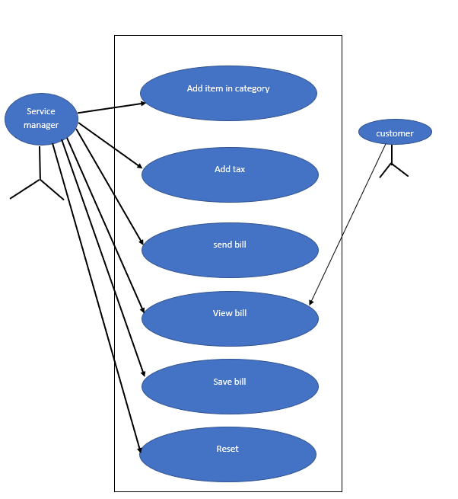

1. **Implementation Methodology:**

Expense Tracking is developed using Python. While using this Tracking system, you can easily calculate total bill of the customer. Moreover, the total bill is calculated including service charges and state tax. All you need to do is just fill up the blank boxes with item quantities and click on total button. The program will display your total bill. This system can be used in restaurants, cafe and food truck for calculating bills in a short period of time and it’s not time consuming. It’s easy to operate and understand by users. There is no any error and warning contents in the project.

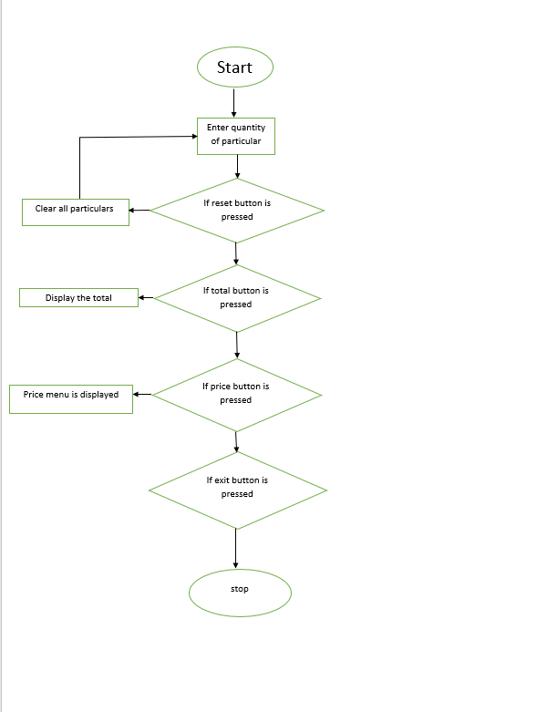

The design is so simple that user won’t find it difficult to use and navigate. To ease the use of the user we even have a calculator added to our system which performs all basic operations like Addition, Subtraction, Division and Multiplication. We’ll display Menu, Order no., Total and Reset. We assure that the project is bug free and easy to use. Since the program is for restaurant or providing services. It will add services charges and state taxes respectively.

#### 

### 5 Technologies to be used

Here we are including the software’s and hardware’s used for developing the project and implementing the project

**A. Software Requirements**

1. Python 3

2. vs code

**B. Hardware Requirements**

1. 2 GB RAM or above

2. Intel i3 Processor or above

3. 32 Bit System or above

**C. Platform:**

Windows 11

### 6 Advantages of this Project

* The total bill is calculated including service charges and state tax.
* All you need to do is just fill up the blank boxes with item quantities and click on total button.
* The program will display your total bill.
* This system can be used in restaurants, cafe and food truck for calculating bills in a short period of time and it’s not time consuming.
* It’s easy to operate and understand by users.
* There is no any error and warning contents in the project.
* The design is so simple that user won’t find it difficult to use and navigate

### 7 Future scope and further enhancement of the Project

In future, this application can be updated with some more food items. Many other latest features will be added. Project will surely be enhanced with respect to looks and appearance and also as per user requirements. Many more functionalities will be added. Some enhancement can also be done with calculator. For now, this application generates the bill but with respect to future application it will be enhanced that it will also print a bill. It can also be used on a large scale. Many more modification can do with menu or prices or tax as well.

It will be easy to use and bug free to all future or upcoming users. This can also be enhanced in future as per customer requirements. Many more features can be added. This will surely help users instead of making a bill manually.

### 8) Definitions, Acronyms, and Abbreviations

|  |  |  |
| --- | --- | --- |
| **Abbreviation** |  | **Description** |
| UCD | USER CASE DIAGRAM |  |
| NO -SQL | Not only SQL |  |
| RAM | Random Access Memory |  |
|  |  |  |

### 9) Conclusion

Time and money are one of the most important factors to any organization. Implementing such software in the college stationery department can surely be a profitable deal as this application helps to carry out tasks with ease and thereby reduces time and money on manpower and materials. This is an open source application so that others can edit and transform this system application according to their needs.

This was our project of System Design Lab about “EXPENSE TRACKING”. Development of this System takes a lot of efforts from us. We think this system gave a lot of satisfaction to all of us. Though every task is never said to be perfect in this development field even more improvement may be possible in this system. We learned so many things and gained a lot of knowledge about development field. We hope this will prove fruitful to us.

References

[1] Noor Azah Samsudin, Shamsul Kamal Ahmad Khalid, Mohd Fikry Akmal Mohd Kohar, Zulkifli Senin, Mohd Nor Ihkasan; “A Customizable Wireless Food Ordering System with Real-Time Customer Feedback.”; 2011 IEEE Symposium on Wireless Technology and Applications (ISWTA), September 25-28, 2011, Langkawi, Malaysia

[2] Sakari Pieskä, Markus Liuska, Juhana Jauhiainen, and Antti Auno of Centria University ofApplied Sciences Ylivieska; “Intelligent Restaurant System Smart Menu That Digital Technology”; coginfocom 2013 4th IEEE International Conference on Cognitive Info communications December 2–5, 2013, Budapest, Hungary.

[3] Ching-suchang, Che-chen Kung, Tan-hsu Tan,” Development and Implementation of an E-Restaurant for Customer-Centric Service Using Wlan And Rfid Technology”, proceedings of the Seventh International Conference On Machine Learning And Cybernetics, Kunming, 12-15 July 2008

*>*

**Thank you**